Zero Generate Purchase Orders PH MFG
Zero Link: http://34.196.137.61/barcode/zero_generate_purchase_orders_mfg.php
- Download the template for upload

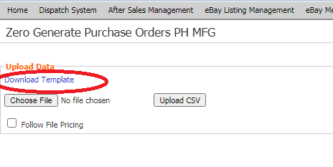
- Fill out the excel/csv file.
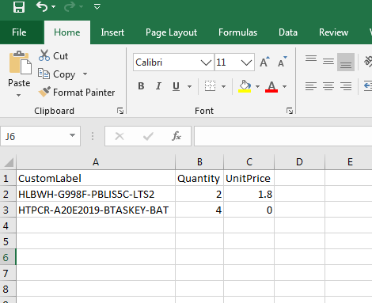

- Upload the excel/csv file. And select the Supplier:
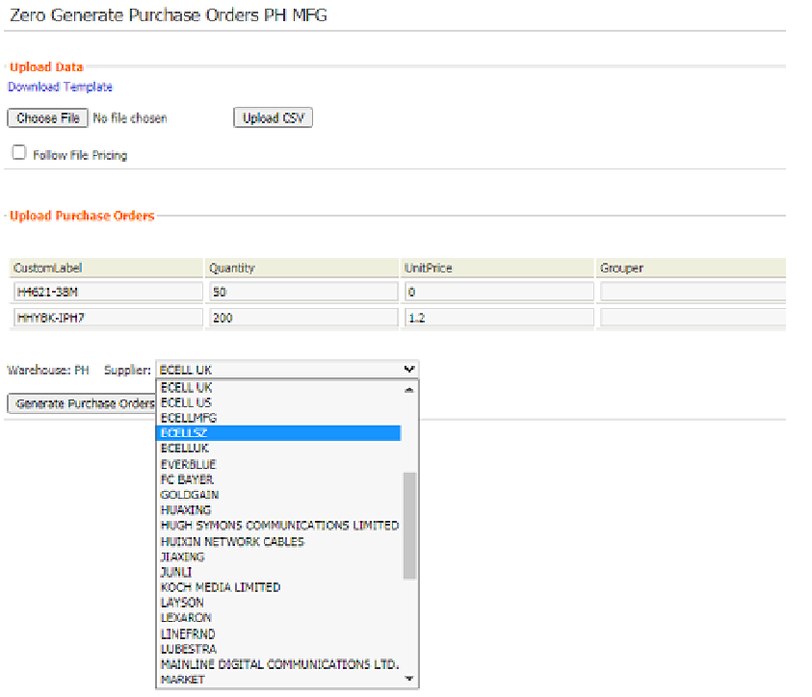
- Click generate purchase orders button:
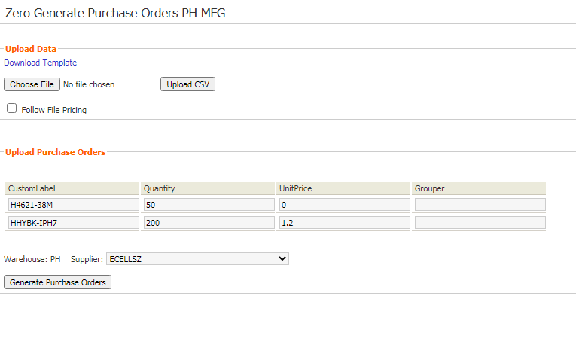
- PO has been generated:

